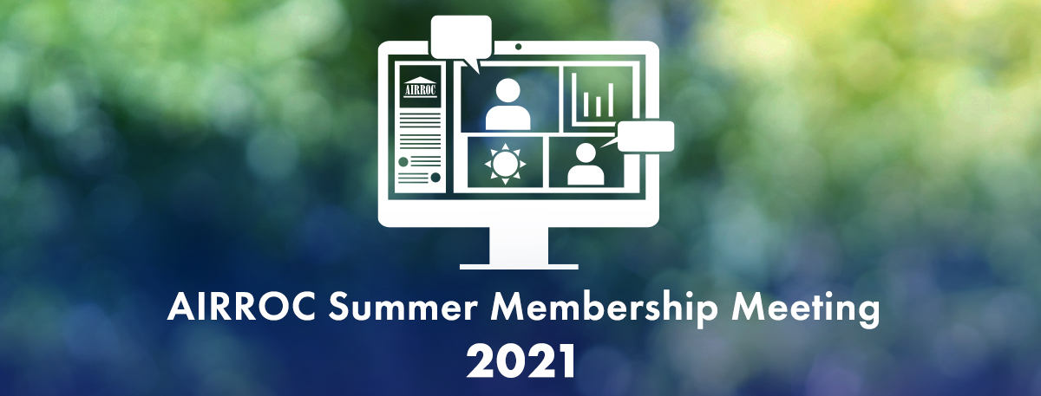
July 13-14, 2021

Schedule of Events
(all times eastern)

July 13, 2021

7:00 AM – 4:00 PM Scheduled Meetings
Via AIRROC Platform and Zoom

Participants can reserve times in the AIRROC platform and will receive meeting invites. Use this chance to connect virtually with others who are attending!

10:30 – 12:40 PM Education Sessions

10:30 AM Welcome and Introductions

A Look at the Legal Landscape

A look at the current state of law concerning business interruption Covid claims, including loss of use v. physical damage and the enforceability of virus exclusions. We will also examine some key findings in the recent landmark UK Supreme Court FCA test case ruling concerning Covid coverage and their potential influence in the United States.

Panelists:
John O’Bryan | Partner | Freeborn & Peters
Michael Merlo | Executive Vice President and Chief Counsel | Aon
Kay E. Wilde | Director of Reinsurance Assumed Claims | Allstate Insurance Company

11:30 AM Break

11:40 AM Using Predictive Analytics to Manage High Complexity Claims

Claim severity, particularly in areas like Auto Bodily Injury Claims, and mass torts, have continued to rise by double digits over the past several years as social inflation has led to run away trial verdicts. The various aspects of Workers’ Compensation claims are also getting more expensive and challenging. At the same time, there are very innovative ways more ways than ever to utilize analytics to help manage high complexity and high severity and complex claims. Now, more than ever, it’s a good time to assess the complexity of your book’s mix and to understand what predictive analytics tools may be at your disposal to help support superior outcomes and decision making around things like: benchmarking outcomes, reserving, predicting which claims may become litigated, which claims are ripe for settlement and other key decision points.

Panelists:
Dan Link | VP, Consultative Analytics | Gallagher Bassett
Megan Nelson | Analytics Consultant | Gallagher Bassett
Carolyn Fahey | Executive Director | AIRROC (moderator)

12:40 PM Adjourn Education

12:45 – 1:30 Group Drop in Rooms
““Drop in” virtually and catch up with AIRROC’s Executive Director or one of our corporate partners and speakers for a casual catch up with other attendees.

Room Hosts: AIRROC, Gallagher Bassett

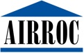

July 14, 2021

7:00 AM – 4:00 PM Scheduled Meetings
Via AIRROC Platform and Zoom

Participants can reserve times in the AIRROC platform and will receive meeting invites. Use this chance to connect virtually with others who are attending!

9:50 AM – 12:40 PM Education Sessions

9:50 AM Keynote Speaker: Randy Maniloff

Top 10 Issues for Effective Reservations of Rights Letters

Randy Maniloff, Counsel at White and Williams LLP and the lawyer behind the well-known monthly newsletter “Coverage Opinions” brings his wit, wisdom and insights to AIRROC. Reservation of Rights letters are a critical tool used by liability insurers to assert coverage defenses. However, if not done correctly, otherwise applicable defenses can be lost. Some courts have been declaring insurers’ reservation of rights letters void, on the basis that they have a deficiency. This seminar will review many facets of reservation of rights letters and discuss things that can be done to ensure that they are enforced.

10:25 AM Break for Panel Switch

10:30 AM SPAC-tacular Ascent: The Rise of SPACs

Our panel will conduct a lively discussion covering all you need to know about the rapid rise of SPACs. 2020 was called the ‘Year of the SPAC’ but 2021 is already on track to surpass it so this session will dive into the market conditions that are driving the surge of new SPAC funds and why we’re seeing such a strong resurgence in SPAC transactions. Further topics to be covered include why tech founders are choosing SPACs over direct listings and IPOs, how SPAC investors select a target for acquisition, increasing competition and what the market trajectory looks like from here.

Panelists:
Gregory Spore | COE Leader, Financial Lines | Guy Carpenter
Ira L. Kotel | Partner | Dentons
Iian Katz | Partner | Dentons
Jack Vales | Partner | Dentons (moderator)

11:30 AM Break

11:40 AM The Scope of an Arbitration Panel’s Authority

A panel of experienced arbitrators will provide their insights into several hot topics in arbitrations. They will address topics such as holding virtual hearings, contract language, custom and practice, honorable engagement and limitations of authority under law.

Panelists:
Susan Claflin | Arbitrator, Umpire, Expert Witness | Claflin Consulting Services LLC
Ann Field | Senior Managing Director of Client Services | Aon
Howard Page | Claims Consultant, HR Page Consulting LLP
Raymond Mastrangelo | Partner | Mound Cotton Wollan Greengrass LLP

12:40 PM Adjourn Education

12:45 – 1:30 PM Group Drop in Rooms
“Drop in” virtually and catch up with AIRROC’s Executive Director or one of our corporate partners and speakers for a casual catch up with other attendees.

Room Hosts: AIRROC, Gallagher Bassett, Mound Cotton Wollan Greengrass

